Shri Anil Kumar, CEO- BSUL meets with Shri Arvind Kumar Sharma, Hon’ble Minister of Energy, Additional Sources of Energy, Urban Development, Overall Urban Development, Urban Employment and Poverty Alleviation, Govt. of Uttar Pradesh.
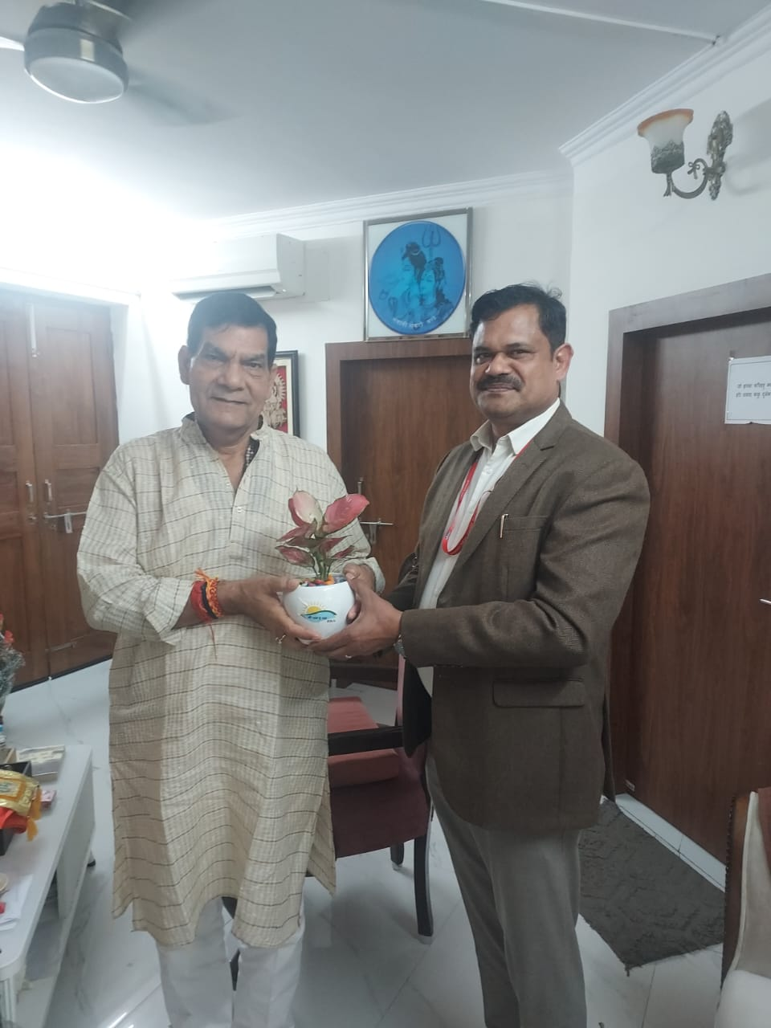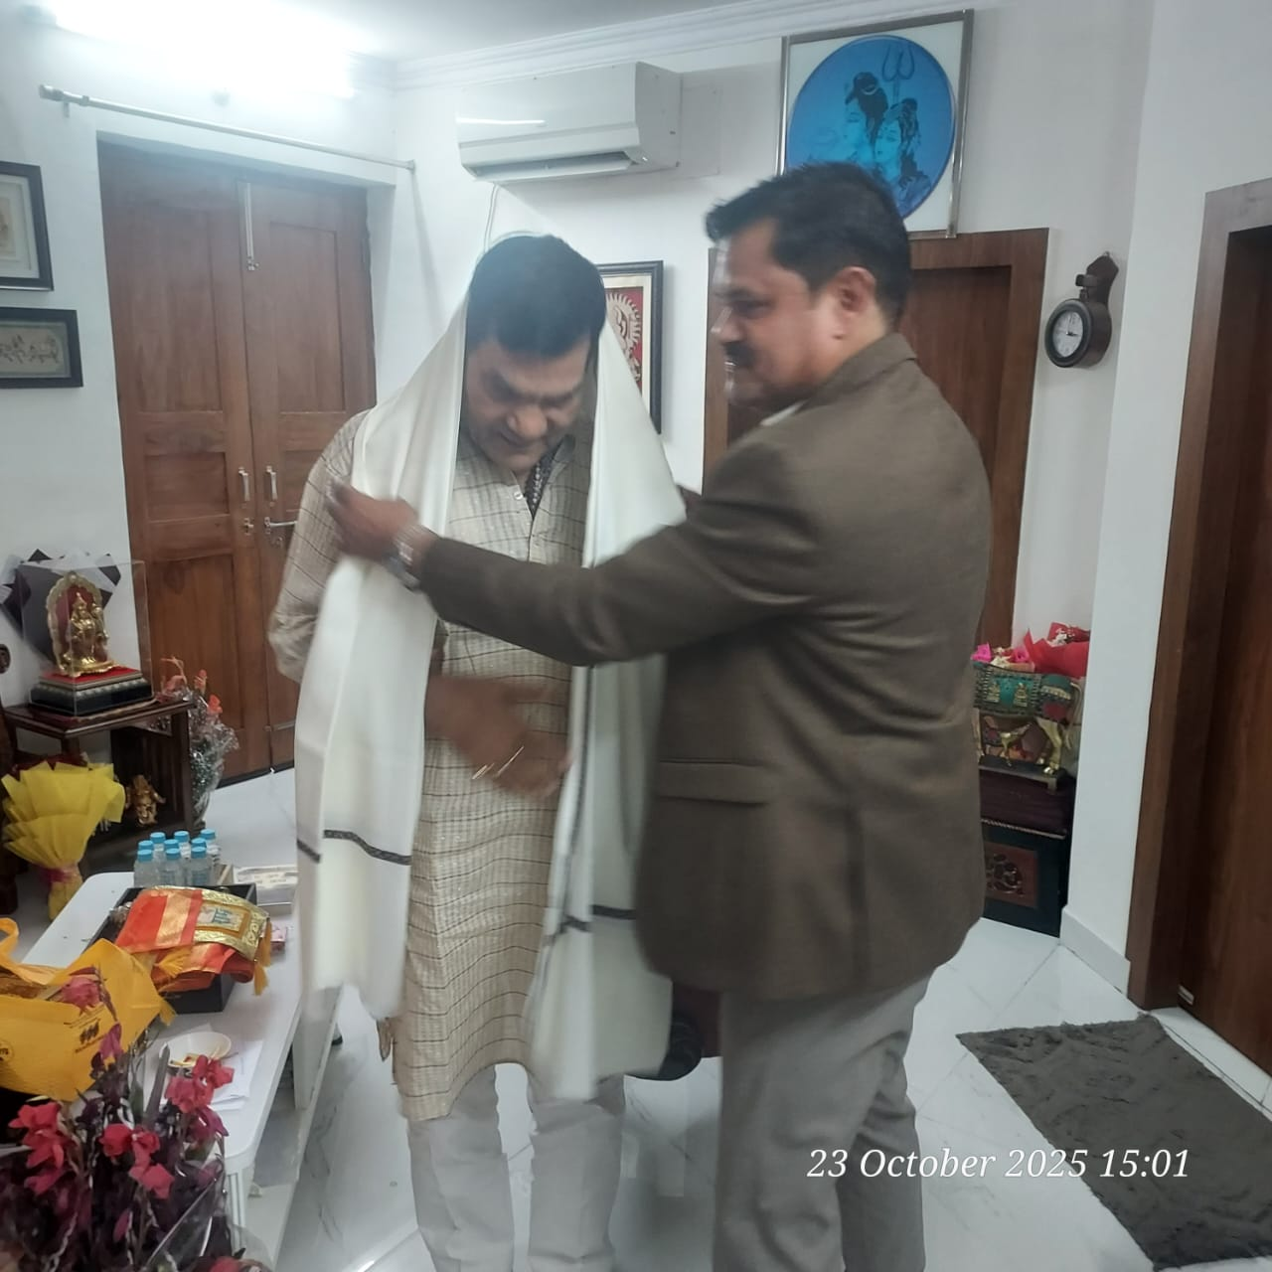
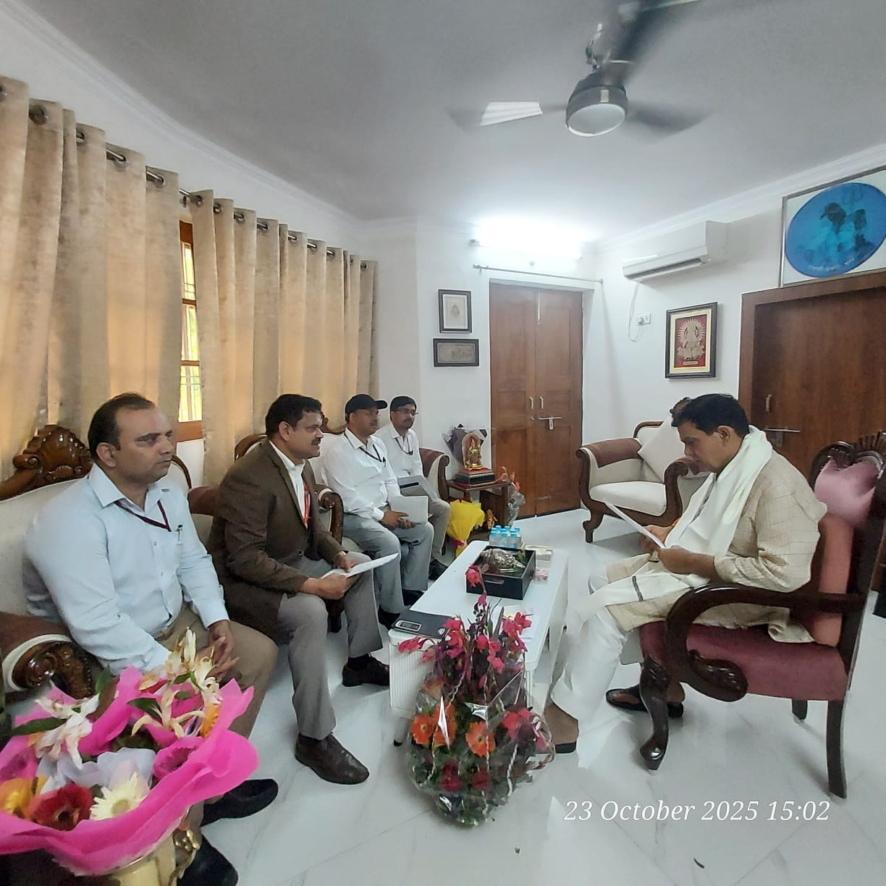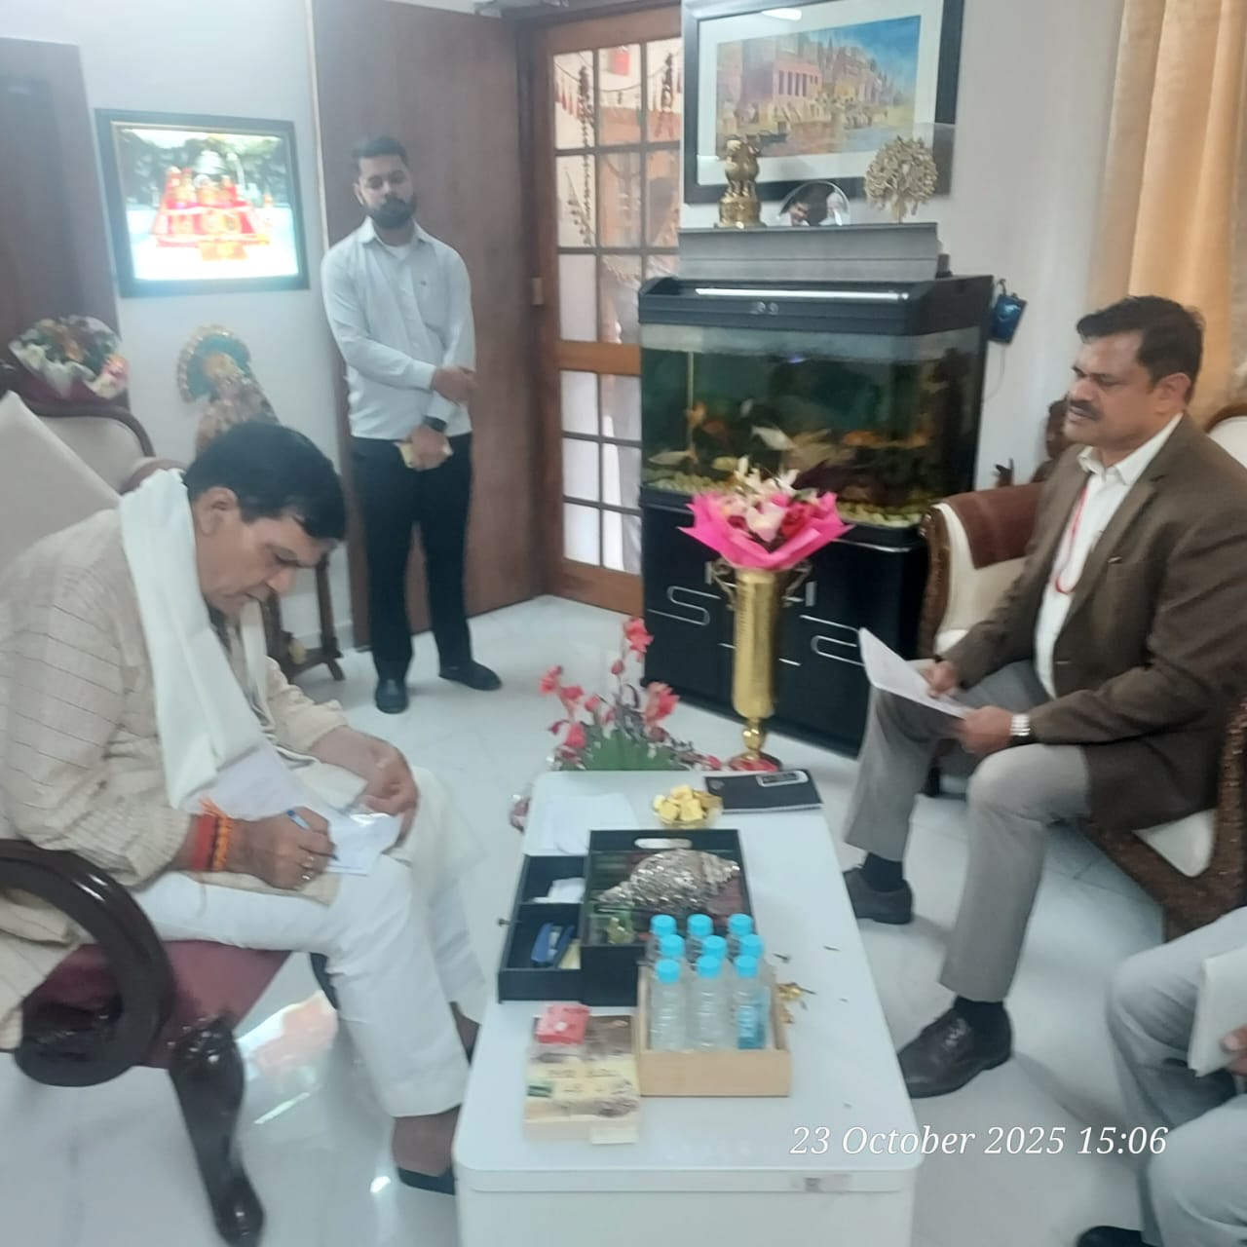

Shri Anil Kumar, CEO, BSUL held a meeting with Shri Arvind Kumar Sharma, Hon’ble Minister of Energy, Additional Sources of Energy, Urban Development, Overall Urban Development, Urban Employment and Poverty Alleviation, Govt. of Uttar Pradesh on 23.10.2025. CEO, BSUL apprised about the progress and critical issues related to the development of Solar Parks & Projects. Hon’ble Minister assured for necessary support to BSUL.

