Shri Anil Kumar, CEO- BSUL meets with Sh. Mayur Maheshwari,IAS, MD- UPPTCL & UPRVUNL, Govt. of Uttar Pradesh.
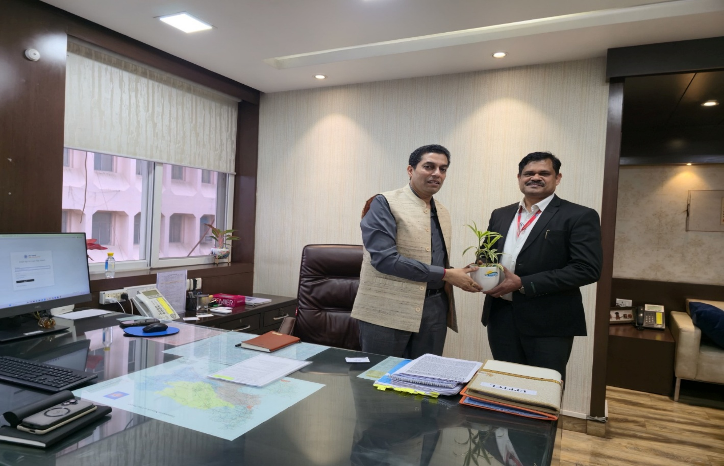
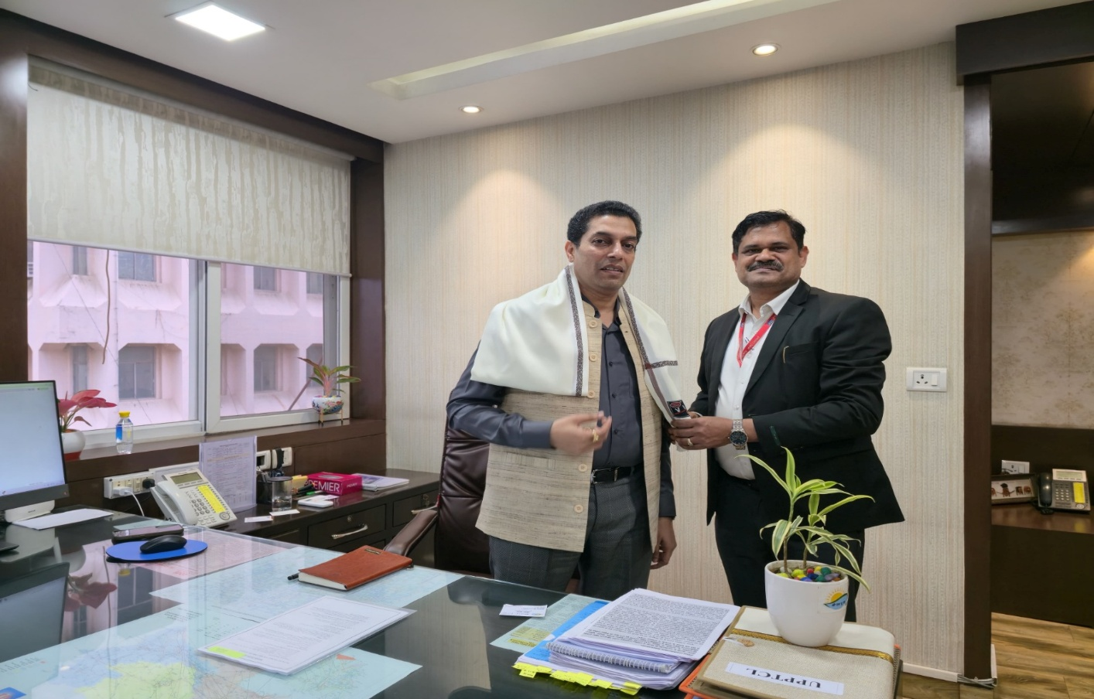
Shri Anil Kumar, CEO, BSUL held a courtesy meeting with Shri Mayur Maheshwari, IAS, Managing Director, UPPTCL & UPRVUNL, GoUP on 04.11.2025 at Lucknow. CEO, BSUL apprised about the progress and critical issues of Solar Parks. MD, UPPTCL assured for necessary support to BSUL

